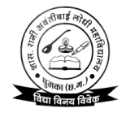
GOVT. RANI AVANTI BAI LODHI COLLEGE, GHUMKA, DISTT.-RAJNANDGAON (C.G.)
web site- www.rablcollege.com Email : govt.collegeghumka@gmail.com Phone – 07744-296940 college code-1904

//CollegeAcademicCalendar2022-23//

 | FIRST WEEK | SECONDWEEK | THIRDWEEK | FOURTHWEEK
JUNE | Printing Prospectus World Environment day | Staff council meeting | Admission Committee Meeting  International Yoga Day | International abdication Nivaran day
JULY | Online Application Start Through university  Time Table Committee Meeting Plantation | IQAC Meeting | Online Application Start Through University | Online Application Start Through University career Guidance & counciling Seminar
AUGUST | TY Class Admission Commencement of SY/TY/PG Second Year Online Teaching  Cleanliness Week | Within15 Days  SY&TY Admission Within 15 Days after result declaration. International Youth day Independence Day(15August)  Celebration of Rani Avanti Bai Jayanti | Within 15 Days  SY & TY Admission Within 15 Days after result declaration. Sweep activity , Orientation ceremony & PTM | Within 15 Days  SY & TY Admission Within 15 Days after result declaration.
SEPTEMBER | World Population Day Program  Induction Program for FY Students  Percent’s Meet Teacher’s Day | Filling up Scholarship & Free Ship Forms Inauguration  National Nutrition Week International literacy day | International Hindi Day Result Declaration Supply Examination Word Ozone Day Amrit Mahotsav | Science Association unit, Unit Test Sweep Activity Staff counciling meeting
OCTOBER | Mahatma Gandhi Jayanti  Placement Cell Activity Unit Test | Preparation of AQAR 2021-22Missile Man APJ Abdul Kalam Jayanti Program | Dussehra Vacation World Food day | Preparation of AQAR Vallabh bhai patel Day  Diwali Vacation
NOVEMBER | Staff counciling meeting  Blood Donation & Awareness programme | Term End Exam Sweep Activity Sector level kabbadi games Financial | Unit Test  NSS Camping | Guest Lectures  Internal Assessment PG 1st and3rd Semester) Literacy Awareness programme
DECEMBER | Preparation of AQAR Unit Test  World Aids Day | Preparation of AQAR IQAC Meeting Internal Assessment  World Human Rights Day | Preparationof AQAR Internal Assessment Winter Vacation Staff counciling meeting | Submission of AQAR Internal Youth Festival Assessment Programmme & competition  Annual Function  University Examination) 1stand3rd Semester)
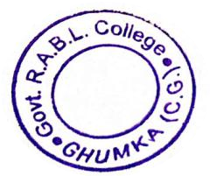
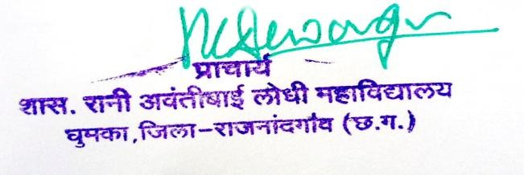
GOVT. RANI AVANTI BAI LODHI COLLEGE, GHUMKA, DISTT.-RAJNANDGAON (C.G.)
web site- www.rablcollege.com Email : govt.collegeghumka@gmail.com Phone – 07744-296940 college code-1904

//CollegeAcademicCalendar2022-23//

 | FIRST WEEK | SECONDWEEK | THIRDWEEK | FOURTHWEEK
JANUARY | University PG Examination Submission of AISHE data  Unit Test | Celebration of Vivekananda Jayanti University Examination | Unit Test | Republic Day Flag Hoisting (26th Jan Prize Distribution Voter’s Day Annual Function
FEBRUARY | Stock Verification | Practical Examination | Practical Examination | Practical Examination National Science Day
MARCH | Annual Examination | Annual Examination World Woman’s Day | Annual Examination | Annual Examination
APRIL | Annual Examination | Annual Examination Staff council meeting | Annual Examination | Annual Examination
MAY | Internal Assessment PG  2ndand4thSemester) |  |  | University Examination)2ndand 4thSemester) Non tobacco Day
JUNE | Planning of Committees for next Academic Year | Printing of Prospectus, Admission Forms Submission of Departmental and Committee Reports to Central Documentation  Committee (IQAC) | Summer Vacation Start | Year End Meeting &Distribution of Committee Work & College Assessment of work load for advertisement for new posts  University PG Examinations

