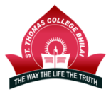
St. Thomas College, Bhilai
Affiliated to Hemchand Yadav Vishwavidyalaya,
Durg, Chhattisgarh

Criterion – 4

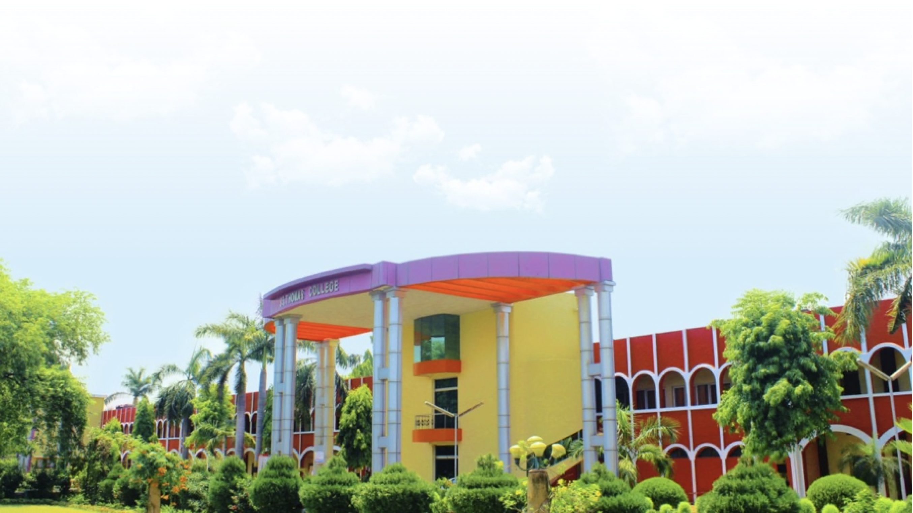
4.4.1: Systems And Procedures For Maintaining And Utilizing Physical Academic And Support Facilities – Laboratory, Library, Sports Complex, Computers, Classrooms Etc.

Submitted to National Assessment and Accreditation Council
2021-22

Maintenance Work for Hostel
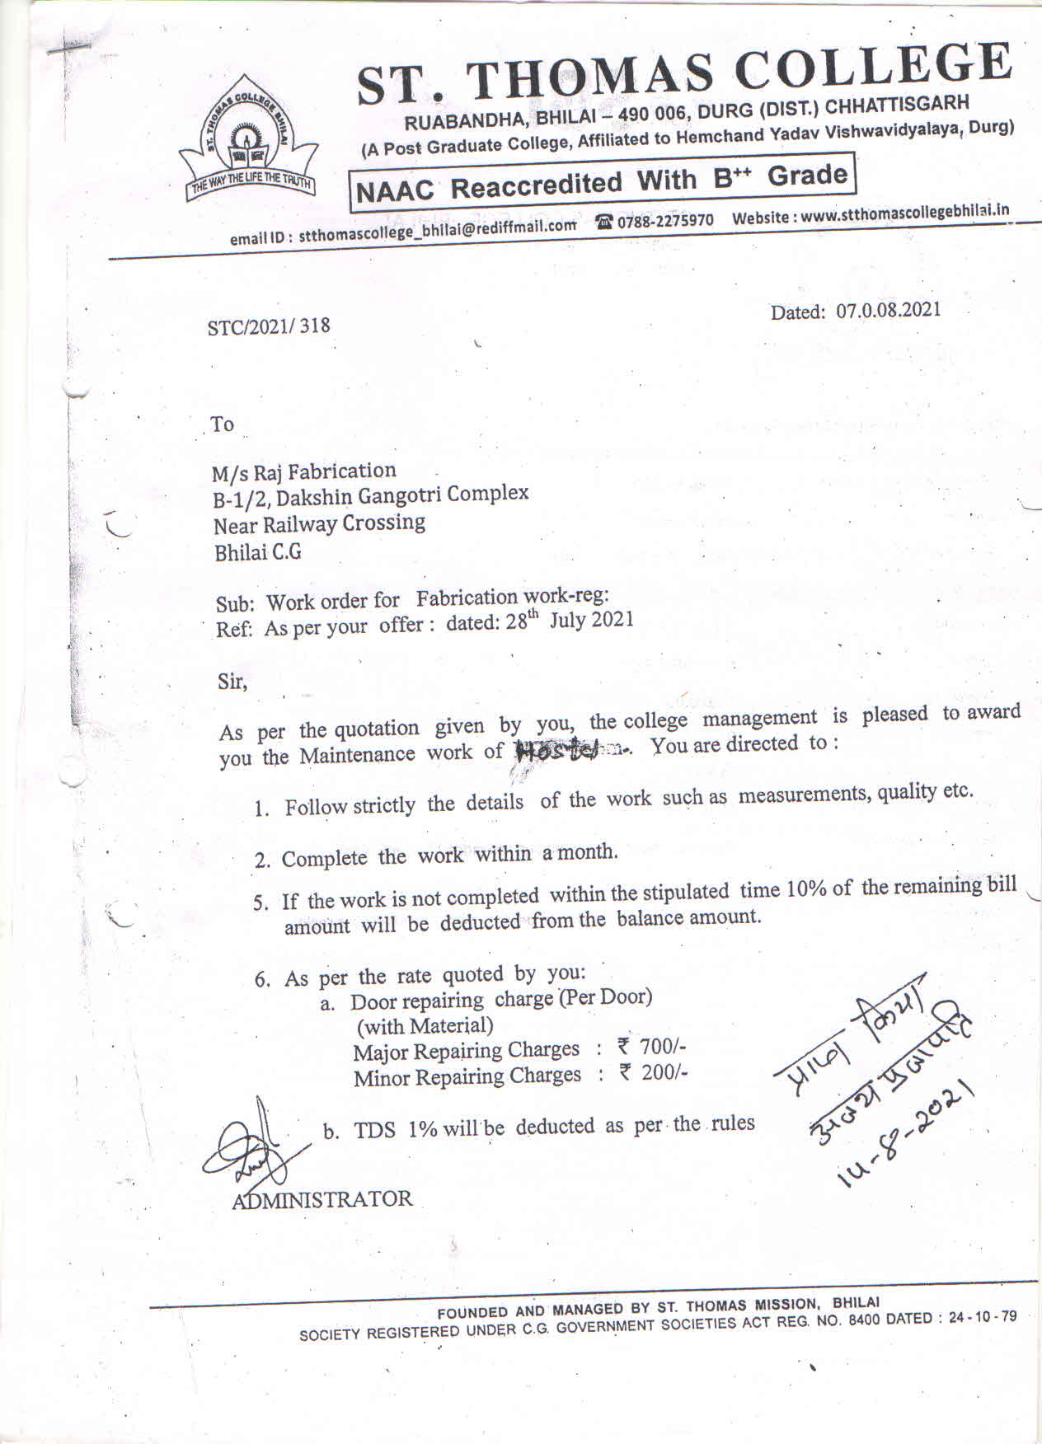

Carpenter Work Order

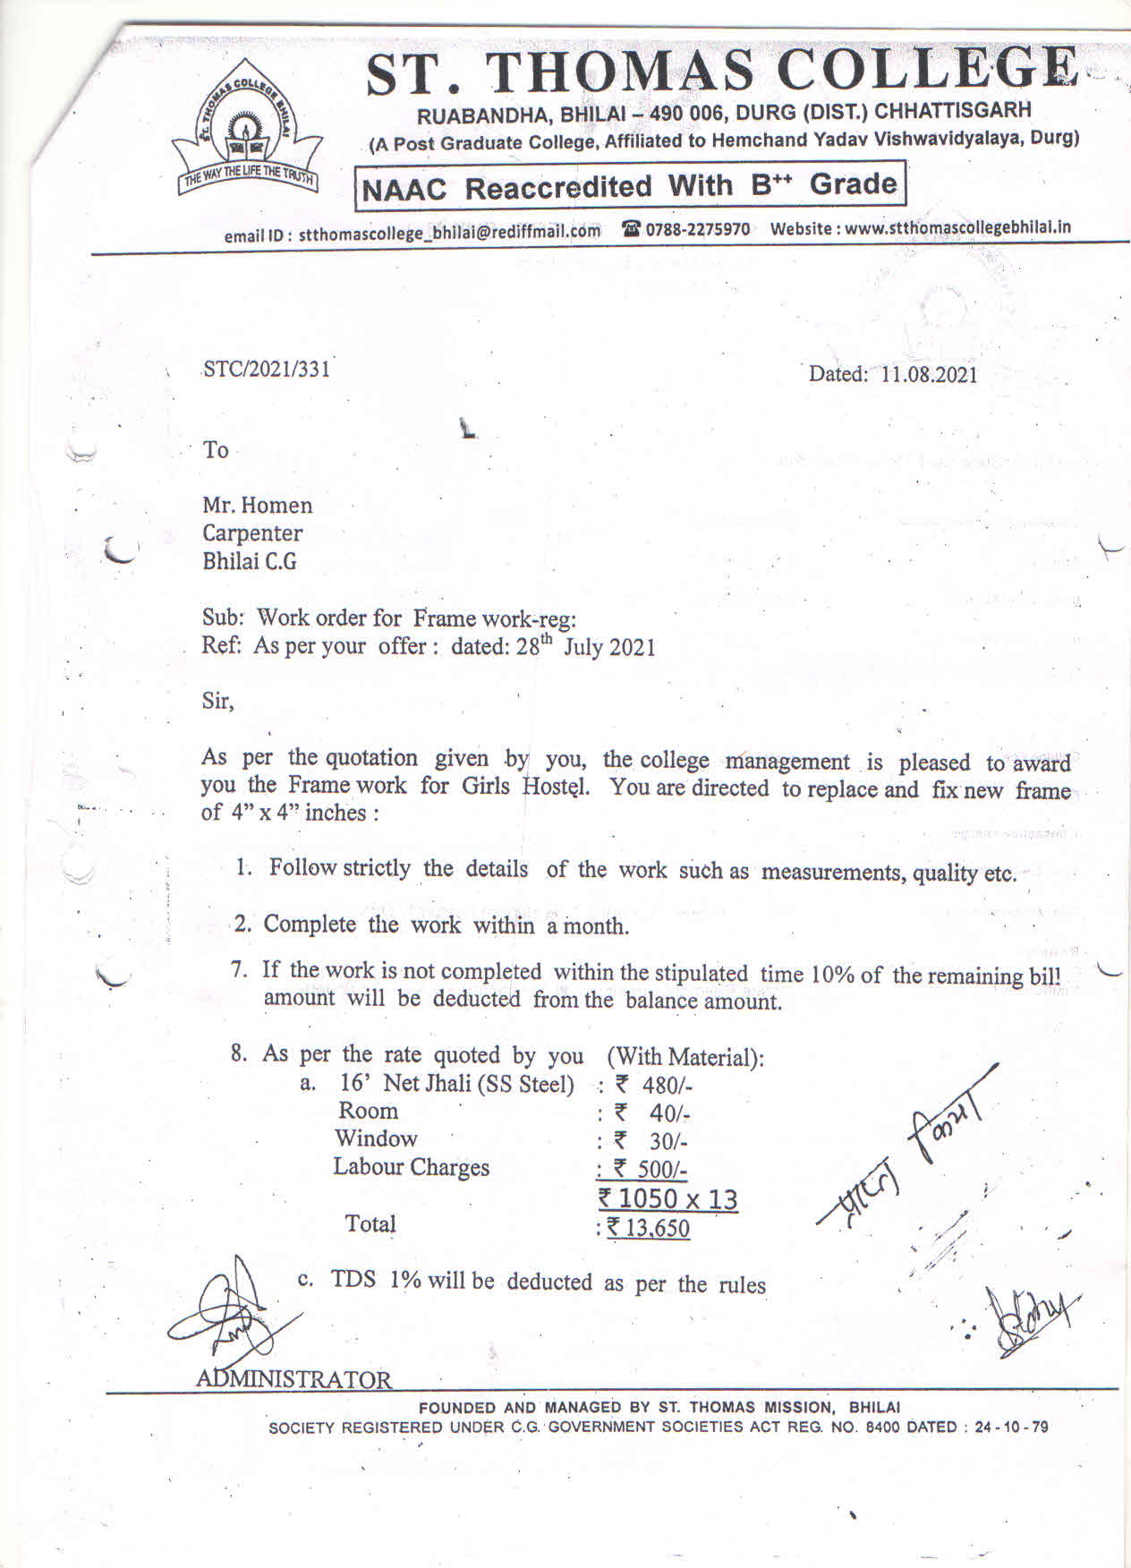

Voucher for Painting
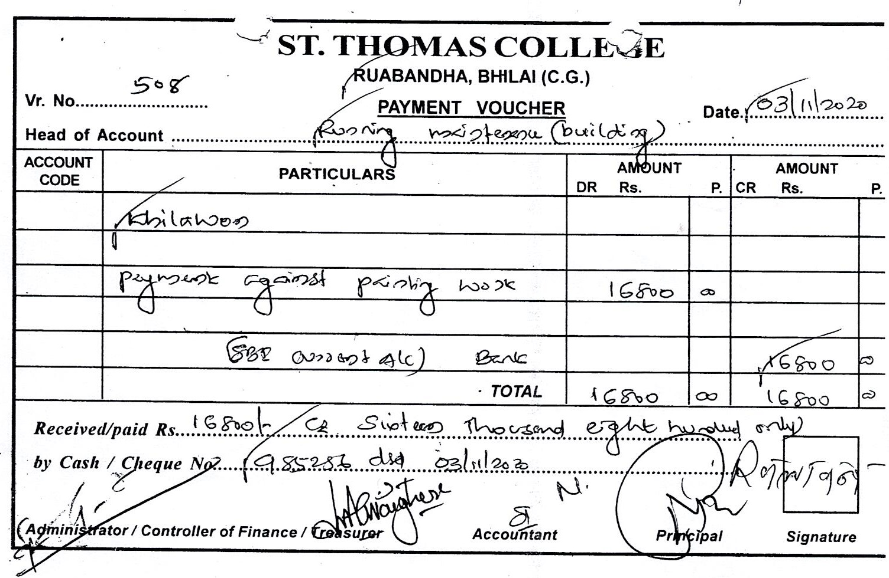
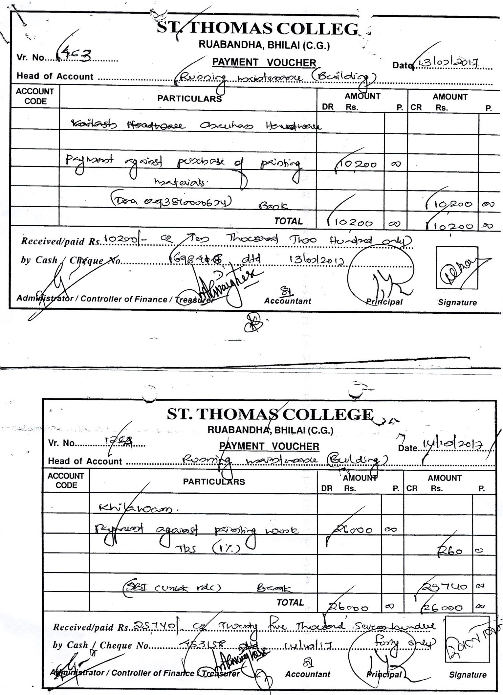

Purchase of Hardware
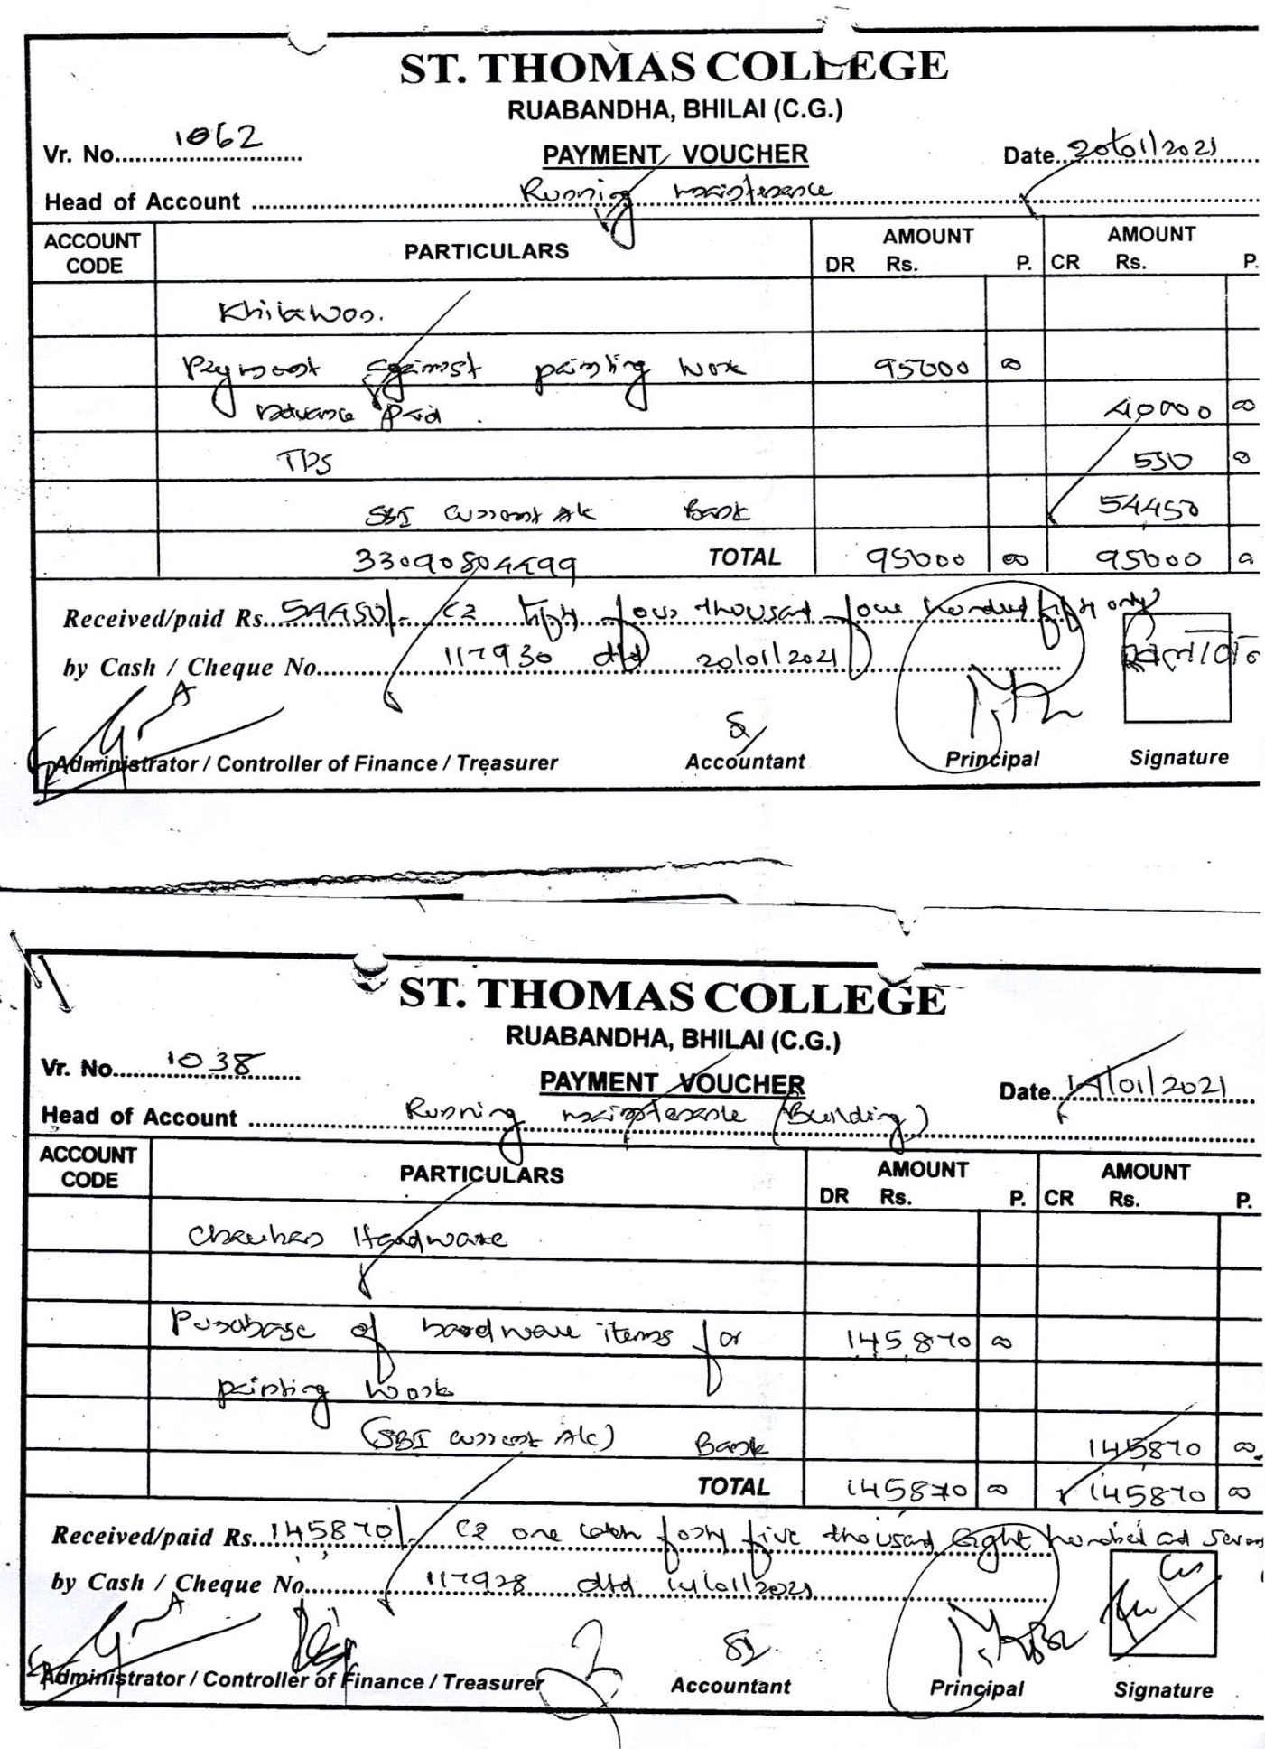
Maintenance Register
